Adidas US Sales Report 2020-21
Project Background:
Adidas is one of the largest sportswear manufactures in the world where they design and manufacture athletic footwear, apparel and accessories through their websites/stores.
The company has significant amount of data on its sales, location of sales, types of products sold, revenue, retailer and other relevant information. This project analyses this data in order to showcase Adidas Sales performance across different regions, retailers, and products and to uncover that factors drive higher revenue and profitability.
Insights and recommendations are provided on the following key areas:
- Sale Trends Analysis: Evaluation of historical sales patterns through different regions and retailers
- Product Level Performance: An analysis of Adidas Products line, understanding their impact on sales and most profitable.
- Regional Comparison: An evaluation of sales and costs by region.
- Underperforming Sales: An insight on underperforming products or regions
An interactive PowerBI can be downloaded here
The SQL queries to inspect and perform quality checks can be found here
The SQL queries and excel functions utilized to clean, organize and prepare data for the dashboard can be found here.
Targeted SQL quires regarding various business questions can be found here.
Dataset:
The dataset contains transactional sales data for Adidas products across the United States. The dataset consists of 13 tables and 9637 fields, each record represents a sales transaction and includes information on product, retailer, location (region, state, city), sales method, and financial metrics such as total sales and operating profit.
Overview of Findings:
Between 2020 and 2021 Adidas Sales showed noticeable functions rather than a consistent trend. Sales peaked in January at approximately $974,808 followed by a steady decline over the subsequent months, reaching a significant low of $327,243 in March 2021. While this drop may be partially attributed to a return to pre-pandemic conditions, further analysis will explore additional factors influencing sales performance and to highlight potential areas for improvements.
Below is the overview from the Tableau dashboard and more examples are included throughout the report. The entire interactive dashboard can be downloaded here.

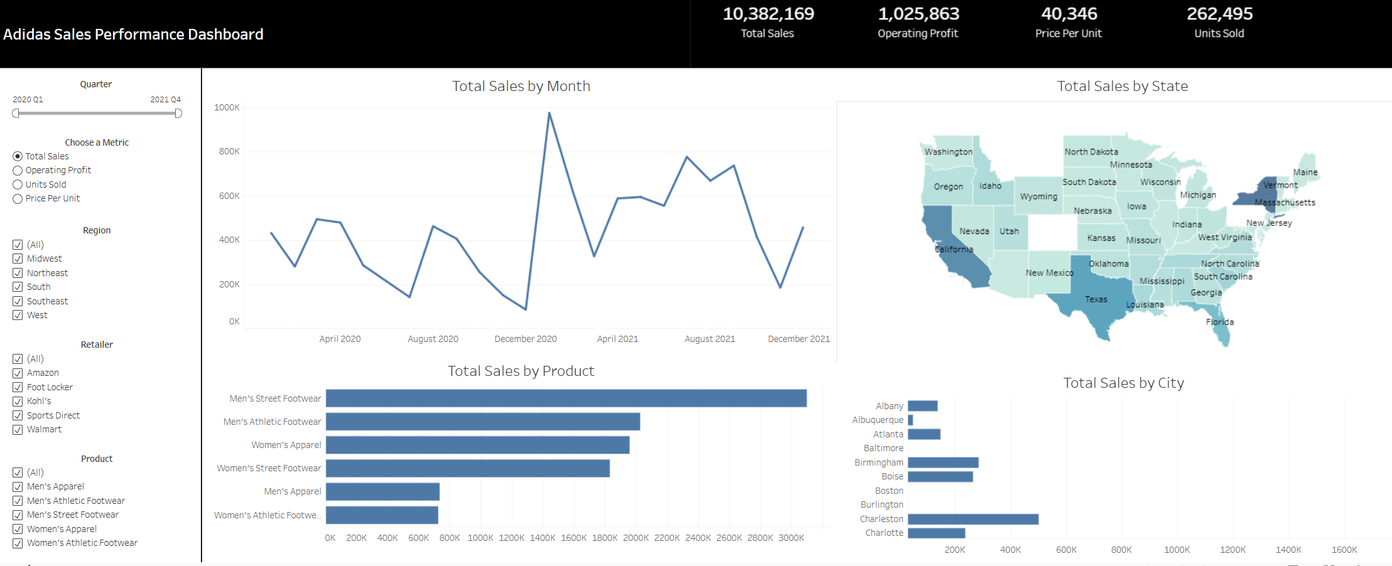
Insights Deep Dive:
Sales Trends:
- The company sales peaked in January 2021 with 25,265 units sold totalling a $974,808 monthly revenue. The peak started in December 2020, which corresponds to the season at the time Christmas, with also Promotions being ran at that time.
- In the start of 2020 Sales started with $423,035 with decreasing in the next month but peaking in March 2020 with $494,669, then dropping of dramatically primary due to COVID-19, and not until July it began increasing until August where it then began to decrease.
- Sales peaked in January 2021, with a decline over the next few months, where it picked up in March and started to be upwards trend until October where Sales dropped from $736,901 in September to $185,632 in November 2021.
Product:
- Adidas Men’s Street Footwear is the highest-performing product, generating $3,100,328 in total sales, significantly outperforming the second highest product Men’s Athletic Footwear $2,025,904. This may be driven by marketing and sponsorship in major sports such as football and basketball.
- While Men’s Street Footwear leads in revenue, Women Streets footwear generates the highest operating profit, indicating it is the most efficient product in terms of profitability after accounting for costs.
- Sales trends show that Women’s Street Footwear experienced a sharp increase in units sold, rising from 254 units in 2020 to 7,769 units in January 2021.Although sales declined in subsequent months, overall performance remained significantly higher than the previous year. This increase may be linked to the easing of COVID-19 restrictions and increased consumer activity in retail environments.
- Other products categories, including Men’s Athletic Footwear and apparel, show relatively stable but lower performance across metrics such as units sold and price per unit, indicating potential opportunities for growth through targeted marketing or pricing strategies.
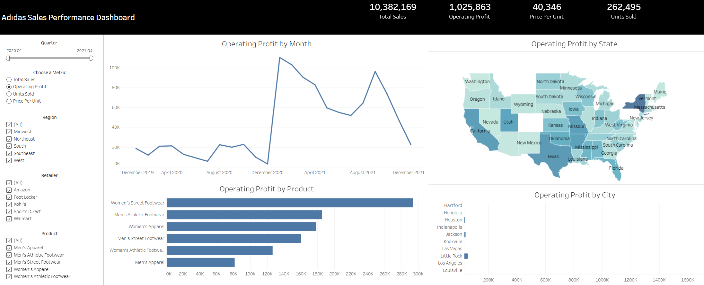
Region:
- California, Texas and New York are the top-performing states across all key metrics, contributing the highest levels of sales and profit.
- States such as Florida, South Carolina and Tennessee demonstrate moderate performance, while Maine and Arizona are among the lowest-performing states.
- Texas experienced a peak in sales in August 2020, followed by a decline until November 2020 after which performance stabilised before increasing again in late 2021. This trend may be influenced by season demand and the gradual easing of COVID-19 restrictions.
- Maine is the lowest-performing state, with approximately 225 units sold over two years, generating around $9,000 in sales and $3,600 in operating profit. This may be attributed to lower population size and reduced market demand compared to larger states.
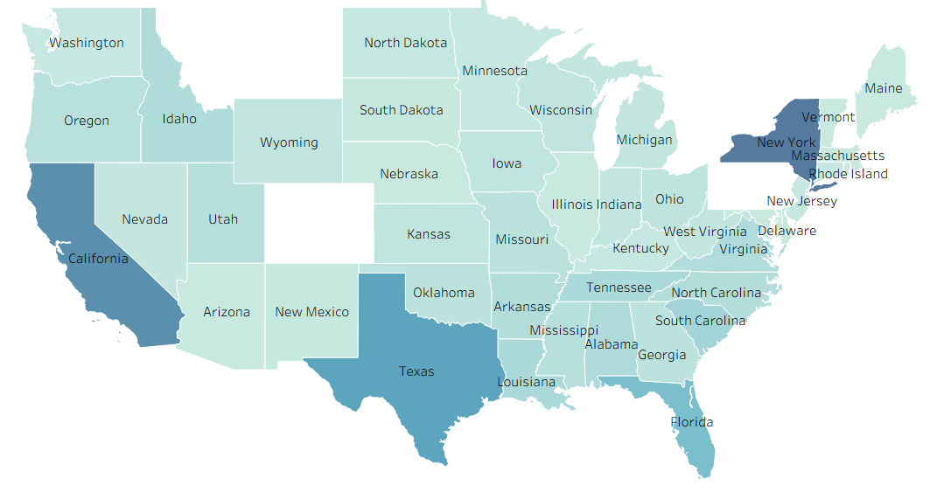
Retailer:
- Adidas has 5 different retailer partners Amazon, Foot Locker, Kohl’s, Sports Direct and Walmart.
- Foot locker is the top-performing retailer, generating $2,836,732 in total sales, making it the strongest sales retailer.
- Kohl’s is the lowest performing retailer, with total sales of $862,125. This may be due to being only available in 7 states compared to its competitors such as Sports Direct with being available in 15 states.
- Despite being available in 5 states Walmart demonstrates strong efficiency, having generated $1,833,110 total sales with 44,324 units sold, indicating high sales volume relative to being available in 5 states.

Recommendations:
Based upon the uncovered insights, the following recommendations have been provided:
- With Women’s Street Footwear generating the highest operating profit, Adidas should consider expanding this product line and increasing targeted marketing efforts. This could include personalises campaigns aimed at existing customers and segments with high female purchasing behaviour to further drive both sales and profitability.

- Lower performing products should be repositioned through targeted promotions; bundle offers or seasonal discounts to improve sales performance and reduce excess inventory.

- States such as Maine and Arizona show consistently low performance across key metrics. Adidas should enhance marketing efforts in these regions to increase brand awareness. At the same time, top performing states such as California, Texas and New York present opportunities for expansion and upselling, given their strong performance

- Adidas should strengthen partnerships with performing retailers, particularly Foot Locker and Walmart, by increasing stock availability during peak periods and running targeted promotional campaigns to maximise revenue.

- As high sales do not always translate into high profit, Adidas should review pricing strategies for lower-margin products while prioritising high margin categories such as Women’s and Men’s Street Footwear to improve overall profitability

- With the post-COVID shift in consumer behaviour, Adidas should invest in both and physical retail and in-store experience to capitalise on increased foot traffic while maintaining a strong online presence to maintain online performance.

